**Twitter Fingers**

Project Plan

Julian Mathis (PM)

Dorian Wood

Anisha Carter

Taylor Clark

Dominique Collins

Sydney Parker



**Contents**

1.0 Introduction 3

1.1 Project Scope 3

1.2 Major Software Functions 4

1.3 Performance/Behavior Issues 4

1.4 Management and Technical Constraints 4

2.0 Project Resources 5

2.1 Team Members 5

2.2 Tools 5

3.0 Security & Risk Management 6

3.1 Technical Risks 6

3.2 Consistency 7

4.0 Project Schedule 7

4.1 Project Task Set 7

5.0 Milestone Chart 9

6.0 Staff Organization 11

6.1 Team Roles 11

6.2 Management Reporting and Communication 13

7.0 Tracking and Control Mechanisms 13

8.0 Version History 14

# **Introduction**

Twitter Fingers was tasked with creating a program/application that will display tweets from pre-approved Twitter accounts that contain financial information, and store these tweets/information to a database so that they can be referenced at any moment of using the program. Our interface will display the information from these tweets in a scrolling fashion, similar to a stock market ticker. This program will be make the user more aware of the latest and most relevant financial news happening in real time. This document will give a precise description of how Twitter Fingers plans to complete this project.

## *1.1 Project Scope*

The scope of this project will be creating an application that will provide the user with new and relevant financial information. This information will help the user to make smart decisions when it comes to handling finances, trading stock, and investing, by providing them with the latest news and advice from well-known tweeters in the world of finance. We will develop a program that easily and elegantly displays financial, investing, and stock related news to the user. To handle all of the information coming in from Twitter, we will need to store and organize this information in a database. We will use a NoSQL database to access our information. One aspect of this program, will be that the user will be able to choose what Twitter accounts they will pull the information from, thus giving the user a personalized experience. The target audience for our program is for anyone who wants to be aware of the latest financial information. This application will be useful for experiences finance minded individuals, and newcomers to the world of trading and investing.

## *1.2 Major Software Functions*

This software application will store tweets in a NoSQL database after they have been shown to the user. This database will be scalable, meaning it will be able to grow as needed for the possible massive influx of real-time tweets coming in from a Twitter Streaming API. The database must be able to organize the tweets and information by a multitude of queries and terms, to allow the user to choose what information they want displayed. Our user interface will display financial/stock related tweets pulled from the Twitter API as readable information to the user. This information will be scrolling across the screen, so that newly tweeted information can be quickly displayed to the user interface and become useful to the user. The user will also be able to choose what Twitter accounts they would like to receive updates from. The program will contain an editable file with a list of Twitter users they want to pull information from. This allows for the program user to have a more personalized experience, being as they can follow tweets from whomever they like. Our application will also perform a statistical analysis on the information in the tweets we stream, so that we will be able to provide the user with more concise and relevant statistical information, as opposed to just raw financial data.

## *1.3 Performance/Behavior Issues*

There are currently no performance or behavior issues.

## *1.4 Management and Technical Constraints*

The final delivery date for our prototype is May 2nd, 2017.

# **2.0 Project Resources**

## *2.1 Team Members*

* Julian Mathis (PM)
* Anisha Carter
* Sydney Parker
* Dominique Collins
* Dorian Wood
* Taylor Clark

## *2.2 Tools*

**MongoDB:** Mongo DB stores data using a flexible document data model. Documents contain one or more fields, including arrays, binary data and sub-documents. Fields can vary from document to document. This flexibility allows development teams to evolve the data model rapidly as the application requirements change.

**Twitter Streaming API:** Twitter has multiple streaming APIs. The Streaming APIs give developers low latency access to Twitter and their global stream of Tweet data. A streaming client will be pushed messages indicating Tweets and other events have occurred, without any of the overhead associated with polling a REST endpoint. A Twitter Streaming API will stream tweets in real-time to display to the user. We will use the tmhOAuth Twitter library to interact with the API.

**Wrike:**  Wrike is a project management application service. It is an online service, which provides aid in task distribution, time management, and encourages collaboration and team efficiency. This will be used to complete tasks and collaborate on work within the team.

**JavaScript:** JavaScript is a lightweight, interpreted scripting language for Web pages. JS is a prototype-based, multi-paradigm, dynamic scripting language, supporting object-oriented, imperative, and declarative (e.g. functional programming) styles.

**Hypertext Preprocessor (PHP):** PHP is a widely-used open source server scripting language, and a powerful tool for making dynamic and interactive Web pages.

**XAMPP:** XAMPP is a web server allowing script to be run in MySQL, PHP, and Perl. We will run a local server on our computers for testing purposes.

**GitHub:** GitHub is a web-based Git or version control repository and Internet hosting service.

**RoboMongo:** Graphic User Interface for managing MongoDB databases.

# **3.0 Security & Risk Management**

## *3.1 Technical Risks*

1. Given that most the project will be completed on personal computers, computer viruses could pose a threat to the project.
2. Given the number of students working on the project on their personal laptops, information loss is a possible risk.
3. Since tweets from Twitter will be pulled in real time, there may be a risk of data overflow in the database. To combat this, we will need to make the database highly scalable.

## *3.2 Consistency*

|  |  |  |  |
| --- | --- | --- | --- |
| **Risk** | **Likelihood** | **Impact** | **Mitigation** |
| Worm/Virus Distribution | Low | * High: An attacker can use our server to distribute worms or viruses onto the computers being used to access the web-application. | * Use authentication keys to allow user access to our server. If the main server is compromised shut it down and use an alternative server. |

# **4.0 Project Schedule**

This project will follow a strict schedule in terms of the development process. This schedule will be followed each iteration, with special consideration to what process the client believes the team should take. The project schedule will be outlined in Wrike, a project management application.

## *4.1 Project Task Set*

Twitter Fingers will use the Iterative software development life cycle model to develop our product. This will be the most ideal approach for this model, as the upcoming iterations serve as a guide for when certain features of the product should be complete. With each iteration, we expect to receive feedback on our product and what features need to be improved upon or added.

**Task Set:**

|  |  |
| --- | --- |
| **Task** | **Description** |
| Requirements Planning | * Meeting with clients (Jan 26) * Discuss requirements (Jan 26) * Prioritize requirements (Feb 16) |
| Design Planning | * Draft design (March 16) * Draw architecture (March 16) |
| Build | * Begin development of web interface (Feb 16) * Develop software and build programs (Apr 6) * Edit documents (May 2) |
| Testing | * Create test cases (Feb 16) * Test all programs for prototype (Apr 5) * Test all requested requirement features (May 2) |
| Deployment | * Distribute and demo product for the client (May 2) * Take feedback from client to build upon in next iteration |

# **5.0 Milestone Chart**

The following chart outlines the requirements/features that our team sees as significant and important to the development of the product. This milestone chart provides the schedule of when these milestones should be reached. This chart will be strictly followed in order to stay aligned with our development plan, as well as to maintain promptness when delivering iterations of the product to the client.

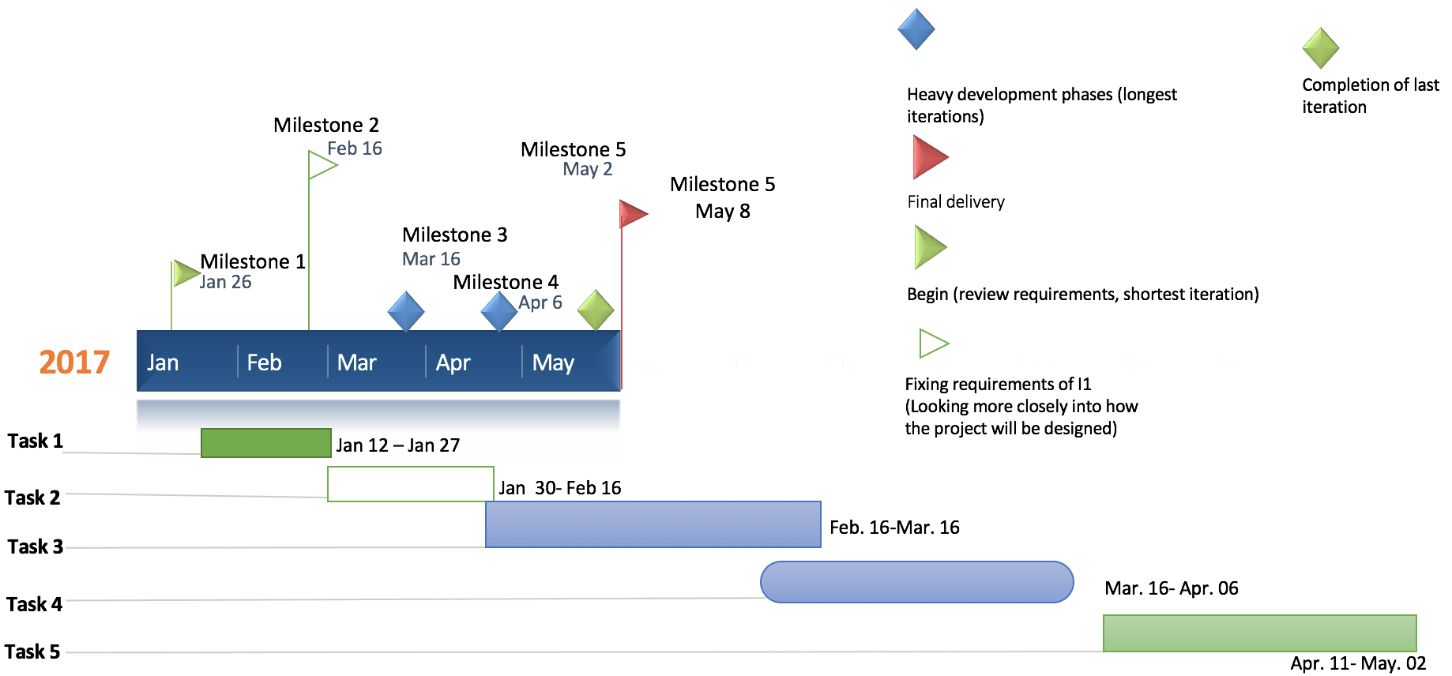

***Task 1*** - Review and critique the requirements and project plan documents from previous semester and design new documents according to the requirements of the client. Create a Wrike project plan to layout the timeline of the product.

* Meeting with clients (Jan 26)
* Discuss requirements (Jan 26)
* Prioritize requirements (Feb 16)

***Task 2*** - Look into getting a basic interface up, Look into creating a DOM Model, Look at some different APIs for twitter, and also the yahoo finance APIs, and work on communicating with any of them also work on communicating with the APIs.

* Draft design (March 16)
* Draw architecture (March 16)

***Task 3*** - Work on development of the website, work on analytical aspect and development of website, work with MongoDB database in order to connect it to the front end, work on and improve Twitter streaming API, lastly improve and fix all documentation.

* Begin development of web interface (Feb 16)
* Develop software and build programs (Apr 6)
* Edit documents (May 2)

***Task 4*** - Have a tested prototype version of the product for release along with updated documentation. The prototype should be pulling desired tweets from Twitter, connecting to MongoDB database, retrieve tweets from the database, and perform statistical analysis on tweets. The prototype will be working on a fully functional website interface.

* Create test cases (Feb 16)
* Test all programs for prototype (Apr 5)
* Test all requested requirement features (May 2)

***Task 5*** - A completed working release of the product that has been tested with minimal bugs along with completed documentation for final iteration. The product will be deliverable with all required features and ready for demo. The completed product will successfully stream tweets, store them to a database, and perform statistical analysis on the tweets.

* Distribute and demo product for the client (May 2)

# **6.0 Staff Organization**

Team Twitter Fingers consists of six team members: Julian Mathis, Dorian Wood, Taylor Clark, Sydney Parker, Dominique Collins, and Anisha Carter. The team is organized by project requirements and application functionality. Although there are three main teams and five main roles, each member is encouraged and at times required to assist other teams and members if and when necessary. We are united in the goal of pleasing our clients with the best product we can develop.

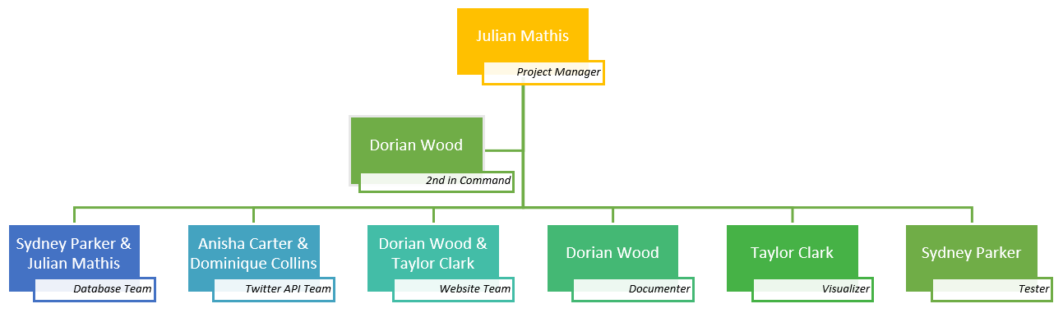

## *6.1 Team Roles*

|  |  |
| --- | --- |
| Position | Responsibility |
| Project Manager  (Julian Mathis) | * Liaison between client and Twitter Fingers * Delegate responsibilities for team members * Understand the application deliverables and requirements * Assist team in proper development and documentation of application * Perform assessment on team members and team as a whole * Create project plan and deliverable schedule * Track team progress toward meeting goals and deadlines |
| Second in Command  (Dorian Wood) | * Assist the Project Manager in communicating with client and team * Help with delegation of duties |
| Database Specialist  (Sydney Park and Julian Mathis) | * Understand MongoDB functionality * Connect MongoDB to website for data storage and retrieval * Sort Twitter data for proper website information |
| Twitter API Specialist  (Anisha Carter & Dominique Collins) | * Assist teammates with application installs * Develop back-end for application using PHP, Java, and Twitter API queries * Identify best ways to stream and filter tweets for stock/finance information |
| Website Specialist  (Taylor Clark and Dorian Wood) | * Design front-end for website * Understand how website will interact with database and Twitter API |
| Documentation Specialist  (Dorian Wood) | * Format documents to ensure consistency, grammar, spelling, and aesthetic appeal are present |
| Visual Specialist  (Taylor Clark) | * Create visually appealing website, logo, and other features of the project * Assist with development of front-end for website using HTML, CSS, and JavaScript |
| Test Specialist  (Sydney Parker) | * Test website for system, user acceptance, and validity testing |

## *6.2 Management Reporting and Communication*

Methods of communication:

* In-person team meetings
* Conference calls
* Formal and informal meetings with client
* GroupMe to announce meeting days, times, and other important information
* Wrike Project Management – Mobile and Web Application

# **7.0 Tracking and Control Mechanisms**

Twitter Fingers will be utilizing GitHub, an online and desktop version control system. GitHub allows the team to track and record changes made to the source files. Twitter Fingers allows the user to connect their Git accounts and code-base with several IDEs, like Eclipse, and push, fetch, and pull code changes through the IDE. Users can also upload and merge code changes through the GitHub team website.

# **8.0 Version History**

|  |  |  |
| --- | --- | --- |
| **Version** | **Date** | **Document** |
| 1.0 | 1/27/2017 | Project Plan Version 1 |
| 2.0 | 2/16/2017 | Project Plan Version 2 |
| 3.0 | 3/16/2017 | Project Plan Version 3 |
| 4.0 | 4/6/2017 | Project Plan Version 4 |
| 5.0 | 5/2/2017 | Project Plan Version 5 |